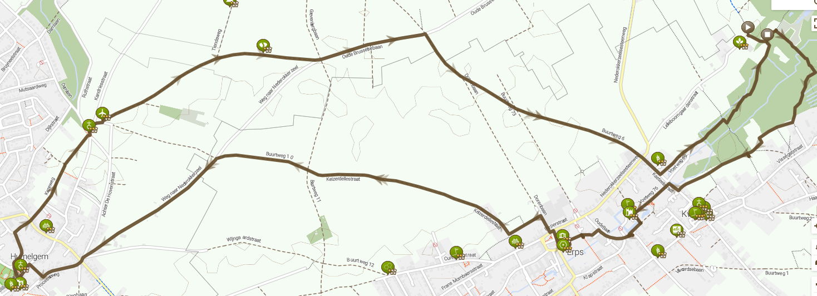
https://www.routeyou.com/nl-be/route/view/7974121/wandelroute/weekend-van-de-trage-weg-2020-route-noord

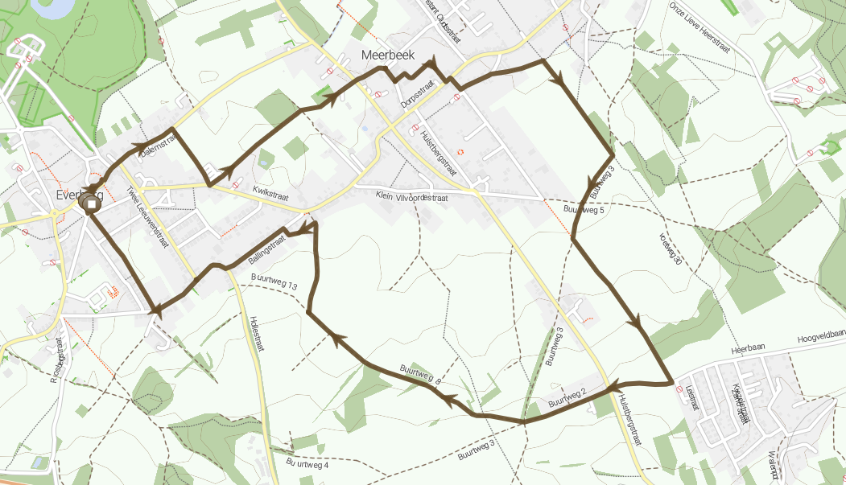
https://www.routeyou.com/nl-be/route/view/7974142/wandelroute/weekend-van-de-trage-weg-2020-kortenberg-route-zuid

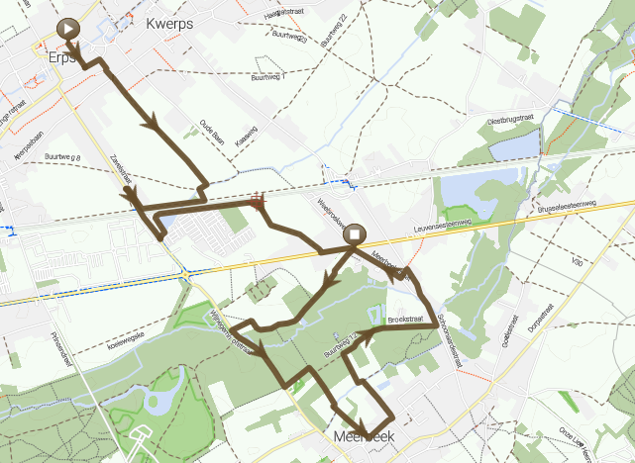
https://www.routeyou.com/nl-be/route/view/7974171/alle-routes/weekend-van-de-trage-weg-2020-verbinding-kortenberg-noord-kortenberg-zuid

