7th Annual JA Company Fair with international participation
Hradec Králové December 12, 2018

Dear friends,

We would like to invite you to the seventh annual JA Company Trade Fair, which will take place on Wednesday, December 12, 2018 in the building of our school. The fair is a unique opportunity to meet with new ideas and try out our contest for the best JA company. For this year we have prepared a number of innovations, such as additional competitions in which all companies have a chance to succeed. No participant fee is charged. We can arrange accommodation for a limited number of participants.

The fair’s programme

8:00 – 9:00 Registration of participating companies, preparing stalls

9:00 – 9:15 Fair opening ceremony

9:15 – 10:35 Presentations

10:35 – 14:30 Sales events, trade

14:30 Closing of the fair and competition results announcement

The fair‘s competitions
The fair is holding several competitions which are judged by an independent jury from among its guests and experts.

These are the competitions:
- The best slogan - create a concise slogan in Czech or Slovak language that appropriately promotes your company, products or services. This competition is voluntary and it will only include those companies which will have sent their slogan by 30 November 2018 to this address: pospisil.zdenek@oahk.cz
.
- The best logo - create a graphically imaginative logo which would impress customers and appropriately represent your company. The logo must not be similar or the same as the logo, which already exists in real companies. This competition is voluntary and it will only include those companies which will have sent their logo by 30 November 2018 to this address: pospisil.zdenek@oahk.cz.

- 90 seconds in front of the investor - a competition for individuals, who will present their company in English, in an imaginary conversation with an investor, within the time limit of 90 seconds. This competition is voluntary and it will only include those companies which will have sent their entry form by 30 November 2018 to this address: pospisil.zdenek@oahk.cz.

- The best seller (price JA Czech) - a competition for individuals who will impress the jury with their behaviour, manners and business skills.

- The best company of the fair – the fair’s mandatory competition and a rehearsal for the April competition for the best JA company. This competition includes the opening presentation of the company, the design of the stand, business and communication skills of individual students, originality and sophistication of the business.

The best presentation – the fair’s mandatory competition - it is a PowerPoint presentation accompanied with verbal commentary. The following aspects will be judged - the time limit, intelligible speech, wit, originality and capturing the audience. Maximum length of a presentation of one company is 3 minutes. For technical reasons, please send us the presentation in advance, by 30 November 2018, 12:00 to this email address: kabrtova.petra@oahk.cz

The best exhibition stand – the fair’s mandatory competition. The following aspects will be judged - the overall appearance of the stand, resourcefulness, creativity and capturing of the business.
- The most likeable company of the fair - the fair’s mandatory competition. Voted by the fair’s visitors.

Organizers‘ resources
The fair will be held in the auditorium and adjacent classrooms of buildings OA, vocational schools and JS in Hradec Kralove. There will be a cloakroom available for the participants to leave their personal items there. Small refreshments will be prepared for the teachers and the jury.

Each company will have two desks and four chairs at their disposal. By prior arrangement, it is possible to bring your own stand (both must be specified in the Application form).

Each company will be located near an electric socket. We ask you to bring your own extension cord. The Internet connection cannot be ensured.

Organizers will provide on-screen presentation of each company for the maximum of three minutes.

Final instructions

Please send the filled in application form (see the next page) by November 30, 2018, 12:00 to this address: pospisil.zdenek@oahk.cz. Should you have any further questions, please send them to the same address.

The company‘s presentation (without sound, lasting the maximum of three minutes) must be sent by November 30, 12:00, the address above.

Due to the limited capacity of our school, the organizer reserves the right to limit the number of registered companies.

We wish much success in business and look forward to meeting you.

The fair‘s organizers
Ing. Zdeněk Pospíšil, Ing. Petra Kábrtová

Under the auspices of:

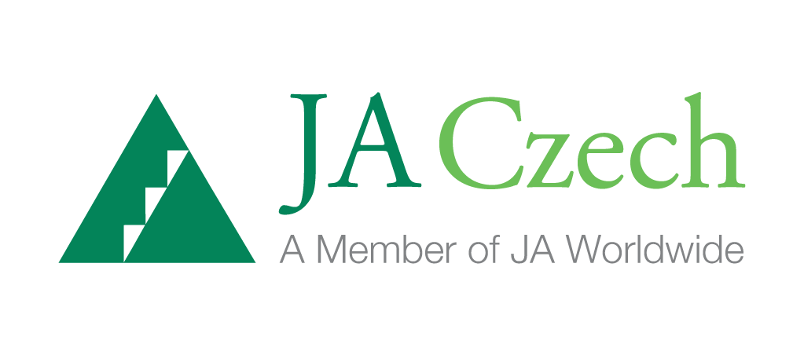
Binding application
7th Annual JA Company Fair with international participation
December 12, 2018 Hradec Králové

Name and address of school:

Contact details of the JA Company programme’s teacher::
Name and surname:
E-mail:
Phone:

Student company / JA firm: (fill in the actual number of registered companies and delete the rest)

1.
Name of JA Company:
Type of business (what it does):
Contact e-mail:
The number of students who will attend the fair:
Screen: yes / no
Custom Stand: yes / no

Under the auspices of:

