Generální štáb |  |  |  |  | Samohybné dělo |  |  |  |  |  | Obrněný transportér
 |  |  |  |  | 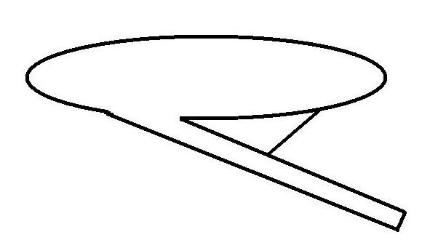 |  |  |  |  |  | 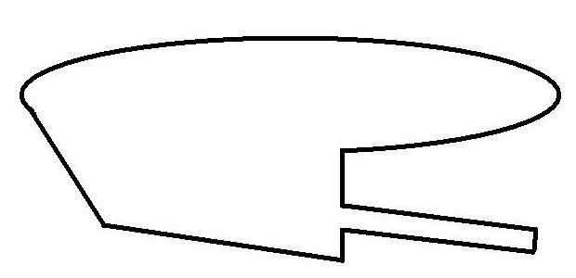
 |  |  |  |  | 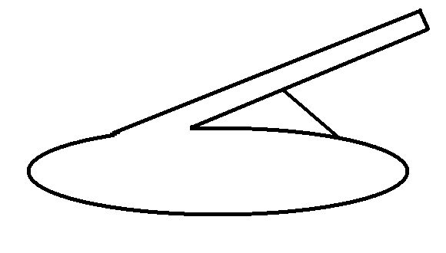 |  |  |  |  |  | 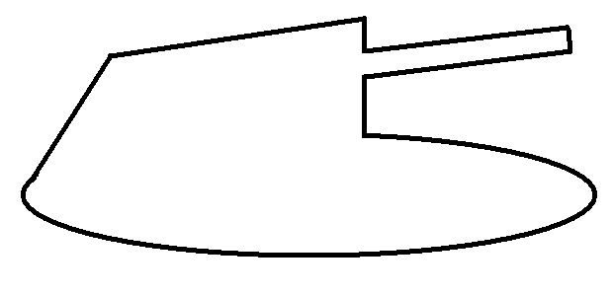
5 | 4 | 3 | 2 | 1 | 2 |  |  | 1 |  |  | 4 | 3 |  | 2 |  | 1
Tank |  |  |  |  | Těžký bunkr |  |  |  |  |  | Lehký bunkr
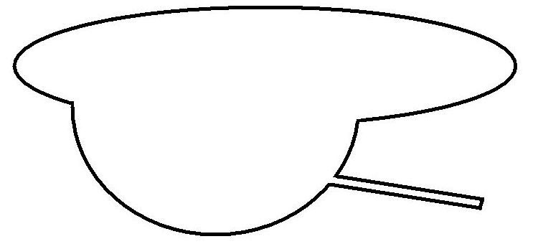 |  |  |  |  | 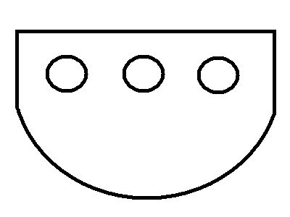 |  |  |  |  |  | 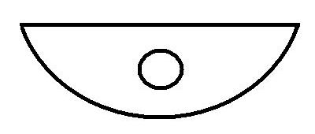
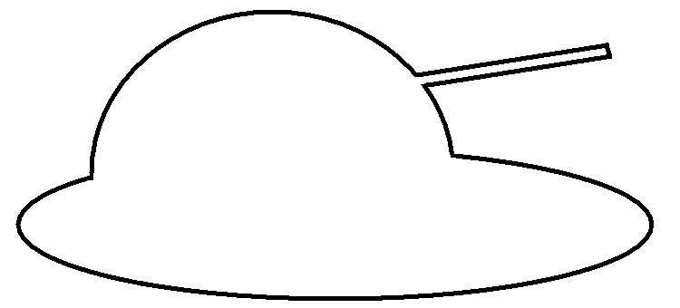 |  |  |  |  | 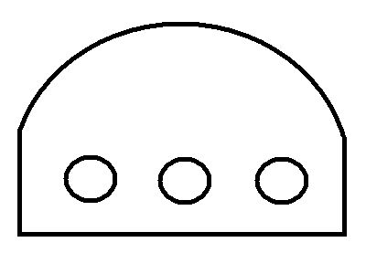 |  |  |  |  |  | 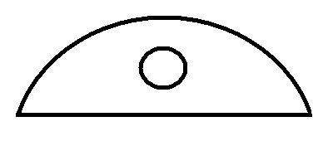
5 | 4 | 3 | 2 | 1 | 5 | 4 | 3 |  | 2 | 1 | 3 |  | 2 |  | 1

